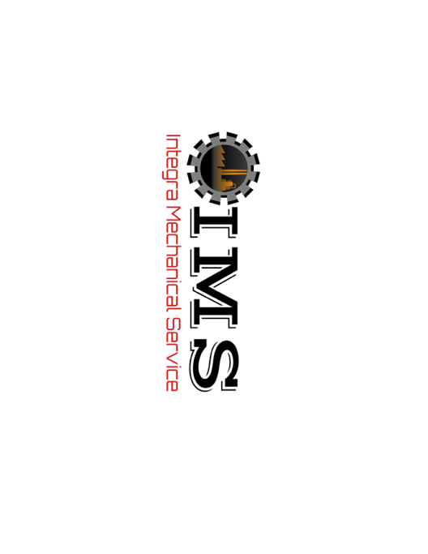Application for **Employment**

706 West 400 South

Heyburn, ID 83336

Phone: (208) 260-2276

Please Print If writing

Position applied for: Date of application:

Name: (first) (last) (middle)

Address: (street) ____ (city) (state) (zip)­­­­ ­­­­_______

Telephone #: ( ) - Cell #: ( ) - Email Address:

Referral Source:

Are you 18 years of age or older: __yes __no

Are you eligible for employment in this country? __yes __no

Have you ever been employed with IMS? __yes __no

If yes, give most recent date and supervisor: __/__/____ ­­­ ________________________

Date available for work: __/__/____ Can you travel out of state to work: __yes __no

Valid Driver’s License: __yes __no

If yes, please provide license number: ________________ State issued: ____

\*\**Answering ‘yes’ to the following question does not constitute a bar to employment. Facts such as date of the offense, seriousness, and nature of the violation, rehabilitation, and position applied for will be taken into account.*

A background check may be required. Have you ever plead ‘guilty’ or ‘no contest’ to, or ever been convicted of a crime? __yes __no

If yes, please provide date(s) and details: ___________________________________________ _____________________________________________________________________________

**List of experiences**

Please indicate any actual experience you have in the following areas: (Please check all that apply and years of experience)

|  |  |  |  |  |  |  |  |  |  |
| --- | --- | --- | --- | --- | --- | --- | --- | --- | --- |
| **Craft Skills** | **Yrs. Exp** | **Work Environments** | | **Yrs. Exp** | | **Training** | | **Yrs. Exp** | |
| Combo Welder |  | Mining | |  | | MSHA 48 Surface | |  | |
| Electrician |  | Food Processing | |  | | MSHA 48 Underground | |  | |
| Iron Worker |  | Cement Plant | |  | | MSHA 46 | |  | |
| Labor |  | Commercial | |  | | OSHA | |  | |
| Mechanic |  | Copper | |  | | CPR | |  | |
| Pipe Fitter |  | Power Plant | |  | | NCCER | |  | |
| Tube Welder |  | Refinery | |  | | NCCCO-Crane Operator | |  | |
| Civil/ Carpenter |  | Solar | |  | | CDL | |  | |
| Equipment Operator |  | Steel | |  | | Over Head Crane | |  | |
| Superintendent |  | | Trash Burner | |  | | Other | |  | |
| Foreman |  | | Coal | |  | |  | |  | |
| Other |  | | Other | |  | |  | |  | |
|  |  | |  | |  | |  | |  | |

**Skills and Qualifications**

Summarize any special trainings, skills, licenses, and/or certificates that may assist you in performing the position for which you are applying: ­­­­­­­­­___________________________________

______________________________________________________________________________ ______________________________________________________________________________